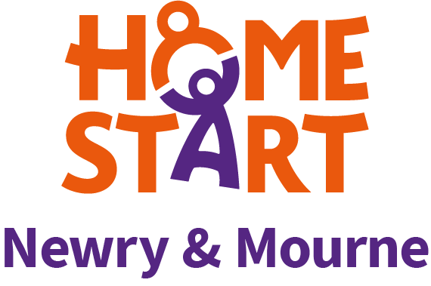
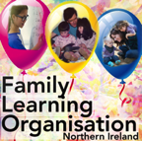 in association with

EMAIL: flo.nireland@gmail.com FACEBOOK: @FLO.NIreland TWITTER: @IrelandFlo

Enabling teachers, parents and children to continue learning
after the Covid-19 pandemic

Dear Principal,
SUMMER SEASON 2021
The Family Learning Organisation (FLO) has now posted all nine short (FREE) videos online which we hope you, the staff and parents have found to be useful. These include:

Liz Jones: Theme: Post pandemic parenting
Everyone has become more anxious and worried during the pandemic. We are now heading towards a new normal. Children are more likely to act out their stress, anxiety or fear through their behaviour (which can, in turn, upset parents, particularly if they are already stressed).
Three short sessions will discuss daily activities and routines:
- Morning routines and daily anxieties
- Afternoon challenges and behaviour
- Evening routines, bedtime and sleep

Kate O’Hanlon: Theme: Thinking, learning and the brain
- Myths and truths about the baby brain
- Habits of mind
- The Washing Line: thinking through writing

Colette: Main theme: Learning maths without realising it: easy games using dice.
Game 1: Lucky 5s: Quick recall for Totals of 5
Game 2: Easy Yahtzee: Learning addition bonds from 2 to 12
Game 3: Crag 1: Thinking about the best choice to make and aiming for the highest total.

All Nine Short Videos Are Available On FACEBOOK, TWITTER AND YOUTUBE

We are following this up with our 3 new Webinars, hosted through Zoom, for your school community. These are:

TUESDAY 25th May at 8pm : Liz Jones:
The new normal, family life after lockdown: how to create a sense of order and reassurance for children.

TUESDAY 1st June at 8.00pm Kate:
The Thinking Child: making learners more aware of their own thinking and sharing ways to improve it.

TUESDAY 8th June at 8.00pm: Colette:
Helping children learn without realizing they are doing maths: some ideas for the summer holidays.

FLO SESSIONS WILL LAST 90 MINUTES

SUBSCRIPTION
If you wish to attend all 3 seminars
Each SCHOOL which registers will have access for ALL STAFF and PARENTS for £100
Individual sessions are £10 each

PAYMENT CAN BE MADE by

PayPal, CHEQUE/ CREDIT CARD OR DIRECT DEBIT

EMAIL flo.nireland@gmail.com and we will send the necessary details

THOSE WHO OPT IN WILL BE SENT THE ZOOM LINK THE THURSDAY BEFORE EACH EVENT.
First link will go out on Thursday 20th May for those who have registered.

We would be delighted if you could spread the word by sharing.

(Registration is now open via email: flo.nireland@gmail.com )

(Registration is now open via email flo.nireland@gmail.com)

FLO TEAM

With a career in nursing, midwifery, mental health, health visiting and teaching, Liz Jones has drawn on her wealth of knowledge, experience and previous research to promote child-centred parenting. Through the Family Learning Organisation, Liz will focus on the family and will explore techniques and strategies that work best for families in these challenging times.

Kate O’Hanlon, a member of the Family Learning Organization for over ten years, is a teacher, psychologist, researcher and accredited trainer of Instrumental Enrichment, a programme dedicated to developing the thinking skills of young people, particularly those who find learning more challenging. Her areas of interest are language and literacy, young people who may be dyslexic and encouraging a focus on thinking skills

As a teacher, adviser and tutor, Colette Delargy has devoted her working life to finding ways of making Maths more accessible to people. She particularly enjoys helping children who think they can’t do Maths overcome their difficulties and succeed with a newfound confidence. As a member of the Family Learning Organisation, Colette will show parents easy, fun activities they can do at home to help their children become better at Maths.

We look forward to hearing from you.

Colette Delargy
Liz Jones
Kate O’Hanlon.

May 2021.

