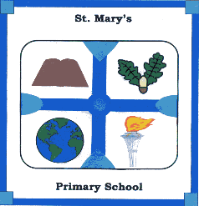
St Mary’s Primary School
Principal: Mrs Oonagh McNally
B.Ed. D.A.S.E P.Q.H.

Telephone No: 028 406 50426
Email: omcnally563@c2kni.net
www.stmaryspsdechomet.com
6 Closkelt Road
Ballyward
CASTLEWELLAN
BT31 9QE

♦♦♦♦♦♦♦♦♦♦♦♦♦♦♦♦♦♦♦♦♦♦♦♦♦♦♦♦♦♦♦♦♦♦♦♦♦♦♦♦♦♦♦♦♦♦♦♦♦♦♦♦♦♦♦♦♦♦♦

11th November 2021

A case of confirmed Covid-19 has been reported in a Primary 1 child. The Year 2/3 teacher has had a positive lateral flow test and is attending to get a PCR test the results of which will be known tomorrow.

The confirmed case in P1 was an entirely asymptomatic case. Any child with symptoms must NOT attend school. We have been very careful keeping our policies and procedures in place with regard to Covid-19 and do not wish it to spread within our school community.

If any parent wishes to collect their child to get a PCR they may do so at any time.

What to do if your child develops symptoms of Covid-19

The most common symptoms of Covid-19 are recent onset of:

- New continuous cough and/or
- High temperature and/or
- A loss of, or change in, normal sense of taste or smell.

Please book a free PCR test even if an earlier one was negative.

The PHA may contact individuals with regard to contact tracing.

Kind regards

Oonagh McNally

